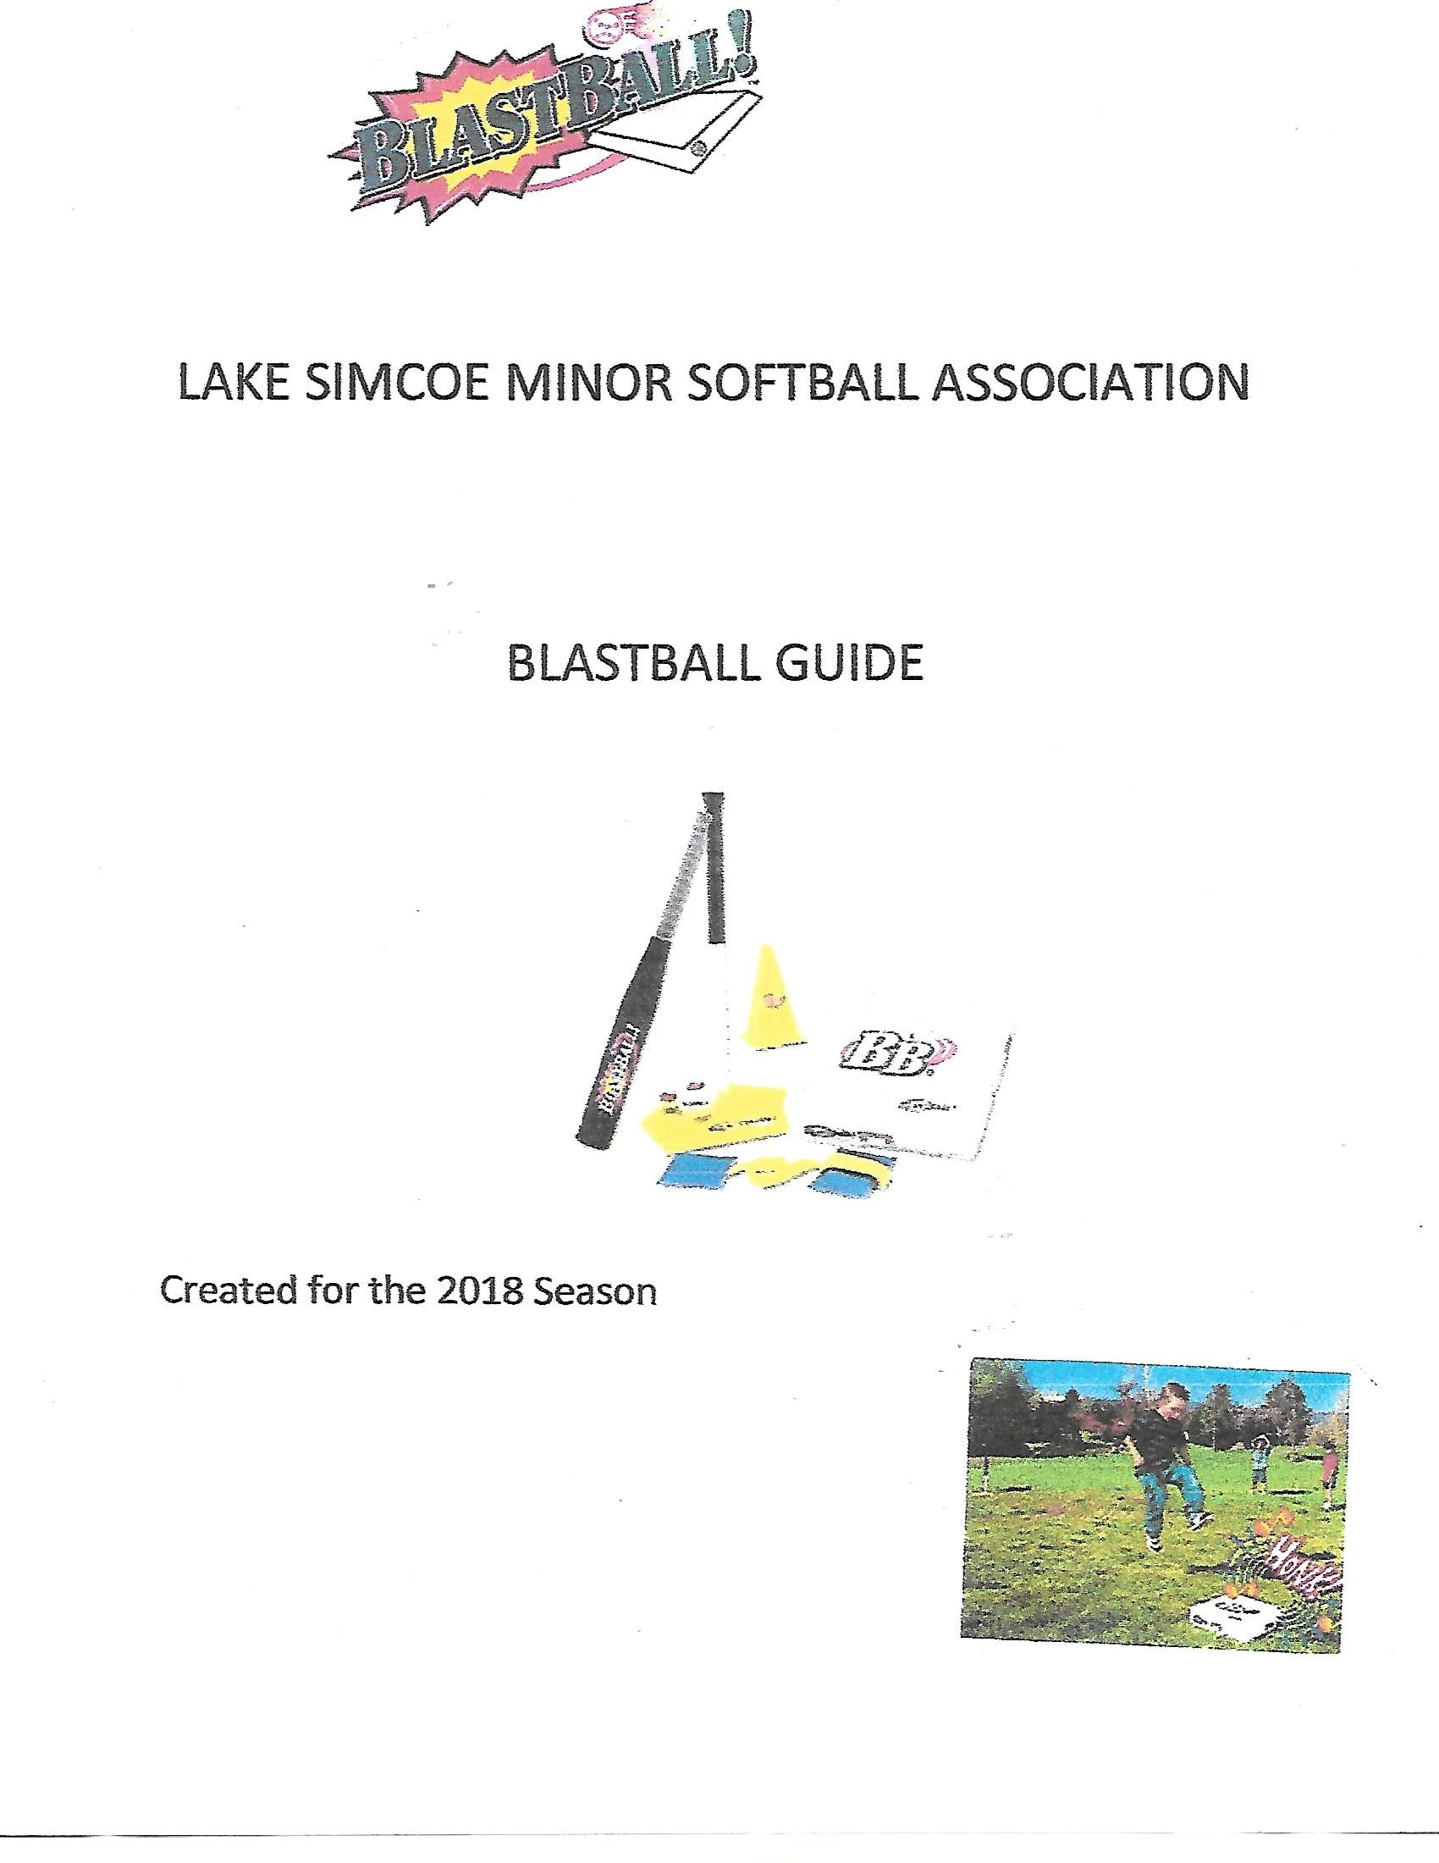
Blastball Coaching Guide
April 2018

Introduction
BlastBall is a new concept for introducing the basic fundamentals of baseball/softball (hitting, throwing, catching, running and fielding) and is aimed at young children. There are no complex rules, no umpires, no personal equipment and a ball diamond is not required.
BlastBall is designed to put the fun back in to the game of baseball and to generate fast-paced action, enthusiasm and fun. Through its simplicity, BlastBall will hopefully allow LSMSA to get young players involved in the game. The teams are intentionally kept small to keep participants active at all times. Parents are encouraged to take the field with their children and help with practice and games.
Each Blastball session will be approximately 35 - 45 minutes in length and will consist of practice time and game time. The first few sessions will consist entirely of practice time in order to teach the participants the basic skills of the game. Subsequent sessions will consist of an increase in game time and a decrease in practice time dependant on how proficient the participants become in the basic skills.

Equipment

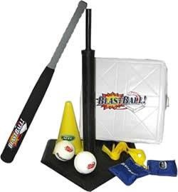
BlastBall is played with equipment which is manufactured using child-safe materials; the bat and ball are made of a soft foam material, removing safety concerns that are created by aluminum bats and hard balls. There are no equipment requirements for the children, as baseball gloves are not required to participate in the game. Helmets will be available. The following materials are required for playing a game of BlastBall and will be available at the diamond each session.
- 1 BlastBat
- 1 BlastBase
- 1 Tee
- 1 Line Marker
- 2 BlastBalls
- 1 Cone

The Game
The goal of LSMSA is to keep teams to 7 players or less. The game can work well with as few as 2 - 3 children per team in the event that a team is short players.
In BlastBall, the defensive team takes the field (defensive players should spread out between the field cone and the BlastBase, and behind the Line Marker) while the offensive team bats. When the batter hits the ball, he or she runs to the BlastBase (the only base used). If the batter reaches the base before the ball is caught in the air, or a defensive player fields it and yells "Blast!" the batter scores a run. If the ball is caught or the defensive player fields it and yells
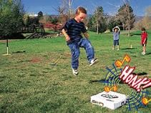
"Blast!" before the batter reaches the BlastBase, he or she is out.
It is easy to tell when a player reaches the BlastBase, because you will hear a loud "HONK!" coming from the base as the player steps on it. Once all batters have had one or two turns, switch the offensive and defensive teams and start again!

There are many variations on the game of BlastBall. As participants become more proficient at hitting, running and fielding the following adjustments can be made to make the game more difficult:
- Lengthen the distance to the BlastBase.
- The fielding player must field the ball and run into a hoola hoop in order to get the base runner out.
- The fielding player must field the ball and throw it into a bucket to get the base runner out.
- The fielding player must field the ball and pass it to another fielder to get the base runner out.
- Add another base.
- Have the base runner stay on first base and run home once the next batter hits.
- Use your imagination and focus on what works.

Field Setup

Setup the field as shown in the pictorial to the left. Place the
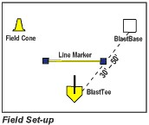
BlastBase and field cone at approximately 45 degree angles from the Tee. The imaginary line between each will be the foul line. The distance will depend on the skill level of the players. Place the line marker 10 feet out from the Tee. No player may come inside this line marker and any ball hit inside the line marker is considered foul and the batter may hit again.

Tips and Fundamentals

The below tips and fundamentals are to be used as a guide and should not be considered absolute.

Hitting Fundamentals
- For proper stance batters should stand adjacent to the batting tee in a balanced, athletic position (feet shoulder width apart, back straight, and bent slightly at waist with butt out). Hands holding the bat should be together (not spaced) and above shoulder. Be sure to have players stand back far enough to be able to extend arms as the tendency at this age is to stand too close to the tee.
- Swing in balance without spinning around, starting with the weight back. Follow through over opposite shoulder. Do not let the bat go.
- The use of a timing step is too advanced at this age and players do better if they learn to swing in balance.

Catching and Fielding Fundamentals
- Player should catch with 2 hands.
- Balls thrown above the waist should be caught with 2 hands with thumbs together.
- Balls thrown below the waist should be caught with 2 hands with pinkies together.
- Ground balls should be fielded with 2 hands either in the “alligator” position or with pinkies together with palms up starting with hand(s) on the ground.
- Teach player to hold ball above head and yell “BLAST” after fielding!

Throwing Fundamentals
- Grip ball along the seam with two or three fingers along with the thumb.
- Point shoulder to target when setting up to throw.
- Throwing arm should be even or above the height of the shoulder.
- Step with opposite leg toward target when throwing.
- Follow-through to opposite pocket when throwing.
- Remember in BlastBall® all throws go to the coach near the BlastTee. No throws are made on the runner or to the BlastBase!

Base Running Fundamentals
- After hitting the ball, lay bat down – do not throw bat!
- Run directly to the base.
- Step on the BlastBase and make it Honk!
- Run through – teach player to not stop at the base.

Remember to keep the fundamentals fun, basic and simple after all, the key to BlastBall® is learning by doing!

LSMSA Blast Ball Practice Plans
Coaches should show up early for the first session and will be given jerseys to distribute to their team. Proceed to your area of the field as designated on the schedule. Once your team has gathered coaches should introduce themselves to their team and try and get their players to introduce themselves. Encourage parents to stay with their children and participate in the practice. The listed times should be used just as a guide. If an activity is going well continue with it. If an activity is not going well move on to something else and come back to that activity later.

Warm Up

Each session should begin with a 2-3 minute warm up. Players this young do not require a warm up in order to physically prepare their bodies for baseball although a warm up is recommended in order to get players mentally prepared to start the session. This also provides a regular routine and encourages the players to perform the same activity together as a team. Warm up activities could include a combination of the following:
Basic stretching Red Light / Green Light Follow the Coach (shuffle
Arm circles Animal movements F-B-L-R)
Short jog – Variations of Tag Simon Says forward/backward Relay Races Any other school yard type
Jumping jacks games

Session 1

1.0 Introductions
Introduce yourself to the players and parents. Encourage the players to introduce themselves. Remind parents they are encouraged to assist with the games and practices.

2.0 Take attendance 3.0 Warm up (3 min) 4.0 Introduce Equipment (5 min)
Introduce the players to all the equipment which is used in Blastball. Let them hold the bats and balls. Show them the tee and let them jump on the BlastBase to hear it honk.

5.0 Practice (25 min)
For the first few sessions it is anticipated that it will take longer to demonstrate these new skills and get players organized and setup so we have allowed more time than normal for each drill. If you find the players attention is starting to wander modify the drill or move on to the next activity.

5.1 Fielding Ground Balls (5 min)
Coaches/parents roll ground balls to the players. You can use the BlastBall or larger balls. Teach players to get in front of the ball and trap it with two hands (like an alligator’s mouth). Have the players yell “Blast” occasionally as practice for the game.

5.2 Catching (5 min)
Introduce catching using the beach balls, BlastBalls, tennis balls and bean bags. Teach the players that when catching anything above the waist put your hands up and your thumbs together. When catching below the waist put your hands out and keeps your pinkies together. Pair each player up with a coach/parent or take turns tossing to each player. Players can try to return throw the ball back but do not focus on technique at this point.

5.3 Hitting and base running (12 min)
Hitting - review with the players the proper stance and technique as described in the hitting fundamentals. The tee should be set even with the batters waist. Have the players hit towards the fence or backstop with as many repetitions as possible per player. Use BlastBalls, tennis balls or even the large balls.
Base running and Throwing – while each player takes a turn hitting introduce the remaining players to base running and throwing. Refer to the base running and throwing fundamentals above. For base running, teach the player to step hard on the base to make it honk and continue running straight through the base. Place a coach or parent just beyond the base giving out high fives as a way to encourage the base runner to run past the base. Demonstrate. If the players get tired of base running have them attempt throwing.
For throwing, ensure the player is stepping forward with the foot opposite the throwing hand. Alternate between throwing and base running to keep the players attention. More attention will be paid to throwing in the next session.
5.3.1 Variations:
- Have the player’s line up single file and take a couple of practice runs.
- Have a coach/parent hit or roll the ball to a volunteer in the outfield with the player running upon release of the ball. The volunteer can yell blast once they field the ball to demonstrate how the actual game is played. Of course
the volunteer will never be able to field the ball before the base runner makes it to the BlastBase.
- Have the player throw or roll the ball before running to the base.

6.0 Free Time (5 min)
If there is time left play a fun and easy game or give the players some free time to practice whatever skill they would like such as hitting of the tee. Alternatively, organize a mini BlastBall game amongst your own team.

Session 2

1.0 Re-Introduction
Re-introduce yourself and have the players introduce themselves again.
2.0 Take attendance
3.0 Warm up (3 min)
4.0 Practice (30 min)

4.1 Throwing (10 min)
Demonstrate how to correctly throw a ball as described in the tips and fundamentals. Have the players throw back and forth with the coaches / parents. Coaches should put their hands out in order to provide a target. Try to correct their form and technique. Switch it up and use tennis balls and bean bags. Roll or toss the balls back to the player.
- Have the players try to throw balls into the baskets of the backstop / screen
- Place one of the large balls on the tee and have the players try to knock it off by throwing tennis balls or bean bags at it. Coaches/parents can retrieve the balls and pass them back to the players.
- Have the players try and throw the bean bags into the hoola hoops lying on the ground. Have them take a step back if they get it inside.

4.2 Hitting and base running (10 min)
Hitting - review with the players the proper stance and technique as described in the hitting fundamentals. The tee should be set even with the batters waist. Have the players hit towards the fence, backstop or to a coach with as many repetitions as possible per player. Use BlastBalls, tennis balls or the large balls.
Base running – while each player takes a turn hitting have the remaining players to base running. Refer to the base running fundamentals above. Teach the player to step hard on the base to make it honk and continue running straight through the base. Place a coach or parent just beyond the base to give out high fives as a way to encourage the base runner to run past the base. Demonstrate.
Mix it up if necessary - have the players throw or roll a BlastBall or soccer kick one of the larger balls before running as a way to add variety.

4.3 Fielding Ground Balls (10 min)
Coaches/parents roll ground balls to the players. Teach players to get in front of the ball and trap it with two hands (like an alligator’s mouth). Have the players yell “Blast” occasionally as practice for the game. Use the different balls that are available.

5.0 Free Time
If there is time left let the players play with the balls or do some more hitting to finish the practice. (5 min)

Session 3

1.0 Re-Introduction / Greeting
2.0 Take attendance
3.0 Warm up (3 min)
4.0 Practice – (30 min)

4.1 Throwing (10 min)
Demonstrate how to correctly throw a ball as described in the tips and fundamentals. Have the players throw back and forth with the coaches / parents. Coaches should put their hands out in order to provide a target. Try to correct their form and technique. Use BlastBalls, tennis balls or bean bags. Roll or toss the balls back to the player. Change it up:
- Have the players try to throw balls into the baskets of the backstop / screen
- Place one of the large balls on the tee and have the players try to knock it off by throwing tennis balls or bean bags at it. Coaches/parents can retrieve the balls and pass them back to the players.
- Have the players try and throw the bean bags into the hoola hoops lying on the ground. Have them take a step back if they get it inside.

4.2 Hitting and Fielding (14 min)
Hitting - review with the players the proper stance and technique as described in the hitting fundamentals. The tee should be set even with the batters waist. Have the players hit towards the fence, backstop or to a coach with as many repetitions as possible per player. Use BlastBalls, tennis balls or even the large blue ball.
Fielding Overhead – while each player takes a turn hitting introduce the remaining players to overhead catching. Remind players when catching over their waist they put their thumbs together. Either toss the badminton birdies in the air or use the racquet. The birdies descend more slowly than a regular ball which gives the players a little more time to track it. Alternatively you could use the beach ball. The players can either try and catch the ball or volley it back with their hands overhead and thumbs together.

4.3 Fielding Ground Balls (6 min)
Coaches/parents roll ground balls to the players. Teach players to get in front of the ball and trap it with two hands (like an alligator’s mouth). Have the players yell “Blast” occasionally as practice for the game. Use the BlastBalls, tennis balls or gym balls.

5.0 Free Time
If there is time left let the players play with the balls or do some more hitting to finish the practice.

Session 4 1.0 Greeting

2.0 Take attendance
3.0 Warm up (2 min)
4.0 Practice (15 min)

4.1 Throwing (5 min)
Reinforce how to correctly throw a ball as described in the tips and fundamentals. Have the players throw back and forth with the coaches / parents. Coaches should put their hands out in order to provide a target. Try to correct their form and technique. Use balls or bean bags. Roll or toss the balls back to the player.
Have the players try to throw balls into the baskets of the backstop / screen or place one of the large balls on the tee and have the players try to knock it off by throwing tennis balls or bean bags at it. Coaches/parents can retrieve the balls and pass them back to the players.

4.3 Hitting and fielding (10 min)
Hitting - review with the players the proper stance and technique as described in the hitting fundamentals. The tee should be set even with the batters waist. Have the batter hit balls to the players in the outfield.

5.0 BlastBall Game (18 min)
Coaches should set up the field as described in the field setup section on page 2. Set the base lengths at 30 feet. Every player will hit before switching to outfield. There may only be time for 2 innings. If the player cannot hit past the line marker after 5 tries the coach should roll the ball out.

Session 5 1.0 Greeting

2.0 Take attendance
3.0 Warm up (2 min)
4.0 Practice (10 min)

4.1 Fielding Ground Balls (5 min)
Coaches/parents roll ground balls to the players. Teach players to get in front of the ball and trap it with two hands (like an alligator’s mouth). Have the players yell “Blast” occasionally as practice for the game. Use the larger balls as well if the player is still having difficulty.

4.2 Throwing and Catching (5 min)
Practice throwing and catching using BlastBalls, tennis balls and bean bags. Remind the players that when catching anything above the waist put their hands up and their thumbs together. When catching below the waist the players should put their hands out and keep their pinkies together. Pair each player up with a coach/parent or take turns tossing to each player. Players should try and return throw or roll the ball back. Alternatively have the players throw into the basket of the backstop or screen.

5.0 BlastBall Game (25 min)
Coaches should set up the field as described in the field setup section on page 2. Set the base lengths at 30 feet. Every player will hit before switching to outfield. There may only be time for 2 innings. If the player cannot hit past the line marker after 5 tries the coach should roll the ball out.

Session 6 1.0 Greeting

2.0 Take attendance
3.0 Warm up (2 min)

4.0 Practice (10 min)
4.1 Hitting - review with the players the proper stance and technique as described in the hitting fundamentals. The tee should be set even with the batters waist. Have one player at a time hit towards the fence or backstop with as many repetitions as possible. Use BlastBalls, tennis balls or even the large blue ball.

4.2 Throwing and Catching
When players are not hitting they should practice throwing. Demonstrate again how to correctly throw and catch a ball as described in the tips and fundamentals. Have the players throw back and forth with the coaches/parents. Coaches should put their hands out in order to provide a target. Try to correct their form and technique. Use tennis balls or bean bags. Roll or toss the balls back to the player. Practice throwing into the screens, use the hoola hoops as targets, catch birdies or beach balls overhead, etc.

5.0 BlastBall Game (25-30 min)
Coaches should set up the field as described in the field setup section on page 2. Set the base lengths at 30 feet. Every player will hit before switching to outfield. If the player cannot hit past the line marker after 5 tries the coach should roll the ball out.

Session 7

1.0 Greeting
2.0 Take attendance
3.0 Warm up (2 min)

4.0 Practice (10 min)
4.1 Hitting - review with the players the proper stance and technique as described the above hitting fundamentals. The tee should be set even with the batters waist. Have one player at a time hit towards the fence or backstop with as many repetitions as possible. Use BlastBalls, tennis balls or even the large blue ball.
4.2 Base running and fielding – While each player is batting the other players should practice base running and fielding. Refer to the base running fundamentals above. Teach the player to step hard on the base to make it honk and continue running straight through the base. Place a coach or parent just beyond the base giving out high fives as a way to encourage the base runner to run past the base. Demonstrate. Have a couple players as runners and a couple players as fielders. Once the player fields the ball they should run to a hoola hoop placed on the field. The fielder is trying to get inside the hoola hoop before the base runner makes it to the BlastBase.

5.0 BlastBall Game (25-30 min)
Coaches should set up the field as described in the field setup section on page 2. Set the base lengths at 30 feet. Every player will hit before switching to outfield. If the player cannot hit past the line marker after 5 tries the coach should roll the ball out.

Session 8 1.0 Greeting

2.0 Take attendance
3.0 Warm up (2 min)
4.0 Practice (5 min)

4.1 Catching
Water balloon fun. Show players how to catch the balloon like it is an egg. Keep practicing until the time is up or all the balloons are all gone. Have a parent pickup and dispose of the broken balloons as they break. If time is left continue with balls and bean bags. Remember pinkies together when catching below the waist and thumbs together when catching above the waist.

5.0 BlastBall Game (30-35 min)
Coaches should setup the field as described in the field setup section on page 2. Set the base lengths at 30 feet. Every player will hit before switching to outfield. If the player cannot hit past the line marker after 5 tries the coach should roll the ball out.

Session 9 1.0 Greeting

2.0 Take attendance
3.0 Warm up (2 min)
4.0 Practice (5 min)

4.1 Throwing and Catching
When players are not hitting they should practice throwing. Demonstrate again how to correctly throw and catch a ball as described in the tips and fundamentals. Have the players throw back and forth with the coaches/parents. Coaches should put their hands out in order to provide a target. Try to correct their form and technique. Use tennis balls or bean bags. Roll or toss the balls back to the player. Practice throwing into the screens, use the hoola hoops as targets, catch birdies or beach balls overhead, etc.

5.0 BlastBall Game (30-35 min)
Coaches should setup the field as described in the field setup section on page 2. Set the base lengths at 30 feet. Every player will hit before switching to outfield. If the player cannot hit past the line marker after 5 tries the coach should roll the ball out.
At this stage coaches have the option of adding second and third base if they choose.
This will depend on the level of ability and focus of the players. Place all the bases 30 35 feet apart. Have a parent or coach at each base to direct the players. To get the baserunner out, fielders need to touch the base ahead of the baserunner. No tagging.

Session 10

3.0 Greeting
4.0 Take attendance
3.0 Warm up (2 min)

4.0 BlastBall Game (30-35 min)
Coaches should set up the field as described in the field setup section on page 2. Set the base lengths at 30 feet. Every player will hit before switching to outfield. If the player cannot hit past the line marker after 5 tries the coach should roll the ball out.
At the stage coaches have the option of adding second and third base if they choose.
This will depend on the level of ability and focus of the players. Place all the bases 30 35 feet apart. Have a parent or coach at each base to direct the players. To get the baserunner out, fielders need to touch the base ahead of the baserunner. No tagging.

5.0 Awards
Players are presented with a year-end award and treat.

Wrap Up

We hope you have found this guide to be useful. Please let us know what worked and what did not so we can continually improve the program.
Coaches and volunteers are critical in putting together and running a well-organized, development based program. LSMSA sincerely appreciates the commitment you have made to your community and hope that the experience was fulfilling for you as well. We also hope that you will continue to support and offer assistance for years to come be it as a coach, board member or volunteer.
Thank you on behalf of the Lake Simcoe Minor Softball Association

